## BCIT’s Sustainable Infrastructure Project wins Envision Gold

**AASHE Case Study**

May, 2019

## Project Overview

The North Campus Infrastructure Project (NCIP) at the British Columbia Institute of Technology (BCIT) in Burnaby, British Columbia, is an ambitious and forward-thinking initiative that leverages the opportunity of infrastructure replacement to advance sustainability at BCIT and the surrounding community.

The NCIP originated with the need to replace a major power receiving substation for BCIT’s Burnaby campus, which was at risk of failure, and to create a new connection to the local electrical utility, BC Hydro. However, this large-scale project became a unique opportunity not just to replace the infrastructure but to take a systems-level view of the campus and its future, and to integrate institutional goals to be a leader in community and campus engagement, climate resilience and environmental responsibility.

The project’s holistic approach and expanded scope led to improvements that include: climate adaptation elements, enhanced outdoor gathering spaces, additional bike lanes and pedestrian greenways, as well as support for increased energy conservation and resilience through BCIT’s collaboration with BC Hydro to design and construct Canada’s first Smart Power Microgrid.

BCIT chose to use the Envision framework for sustainable infrastructure to guide the $46.9 million project, while prioritizing an integrated design process and ongoing engagement of key stakeholders through existing campus plan consultations and project-specific feedback. As a result of this initiative, BCIT became Canada’s first education-sector recipient of the Envision Gold award for sustainable infrastructure.

## Background

Describe the circumstances that led to the start-up of this project

**Climate resilience and ecological footprint**

BCIT recognizes that climate change is an increasingly important factor in campus planning and development. Anticipated climate impacts in the region include warmer average temperatures, extended dry periods in the summer, increased rain and snowfall in colder months, as well as more frequent and intense storm events. In addition, BCIT has commitments to advance towards the following ambitious goals through the institute’s Policy 1010: Become Greenhouse Gas Neutral; Become a Net Energy Producer; Achieve Zero Waste; Become Water Balanced; Become Ecologically Restored; Be Equitable and Socially Responsible; and Be Accessible to all Students and Faculty.

**Integrated campus planning process**

In 2013, BCIT launched the development of a new campus plan, asking staff, students, faculty and stakeholders about their vision for the future of BCIT, and how the campus could be a welcoming place to the broader public. Through a stakeholder engagement program involving design charrettes, open houses, and online submissions, a number of themes emerged, including:

* Walkability improvements;
* Outdoor spaces for gathering and relaxation; and
* Protecting natural habitat through planting native plants and preserving the salmon-bearing Guichon Creek, which runs through the campus.

This input, along with concerns about climate impacts and emergency preparedness, has also prompted BCIT to explore how the Burnaby campus can be an area of refuge for the surrounding community.

**Infrastructure assessment**

In 2015, BCIT conducted a condition assessment of all of its underground utilities. The assessment indicated that the Canada Way receiving station on the north side of campus, responsible for approximately 50% of BCIT’s electrical needs, was at risk of failure. Aging infrastructure presented BCIT with a challenge, but also a unique opportunity to integrate climate adaptation, environmental responsibility, and community engagement into a large-scale infrastructure project.

**Envision Sustainability Framework**

BCIT took this opportunity to employ the Envision framework, a voluntary 3rd party verification process, early in the design phase to assess and measure the extent to which the NCIP contributes to conditions of sustainability across a full range of social, economic, and environmental indicators. The framework guided the project team in leveraging sustainable approaches in the design and construction which will carry through to the project’s operations, maintenance and eventual decommissioning.

## Project Goals

Describe the goals of this project.

**A holistic vision**

The NCIP is part of a much larger and longer-term vision to increase the resiliency of the BCIT campus and surrounding community. While the $46.9 million initiative was initially centred on replacing an aging power receiving station, the scale of the replacement presented an opportunity to integrate key sustainability aspects of the Campus Vision, including new outdoor gathering spaces, carshare parking, greenways, and bike lanes, which had been developed through consultation with the BCIT community.

The project also aimed to demonstrate that standard project priorities such as cost avoidance and financial metrics can be used in concert with sustainability factors shaping campus development. Together, these priorities would contribute towards making the campus an inviting, accessible place for both students and the broader community.

**Long-term sustainability**

Having celebrated BCIT’s milestone 50th Anniversary, BCIT Facilities staff began thinking ahead to BCIT’s 100th Anniversary by steadily embedding sustainability into campus infrastructure development. BCIT’s Policy 1010, established in 2014, now places environmental sustainability at the forefront of all decisions made at BCIT. The NCIP project aimed not only to leverage the Envision framework for the long-term sustainability of the BCIT community, but also to serve as a flagship case study for future projects in the educational sector and beyond.

## Implementation

Describe how the project was implemented, including who was involved.

Once the business case was developed for the project, project leads engaged the entire team of contractors and stakeholders early in the process, collaborating with Stantec, PCL Constructors Westcoast, R.F. Binnie & Associates, and PFS Studio to bring the project to fruition. Having an integrated design team approach enabled all perspectives, from design to construction, to be included in planning, ultimately helping address potential challenges early on and create project efficiencies.

The Envision framework for sustainable infrastructure was also introduced early on in the planning process, and the team researched climate projections for the Metro Vancouver region, to ensure decision-making was guided by these key priorities.

Stakeholder input played a key role in the development. The NCIP not only aligned with the wider campus planning process that was underway at the time, it also undertook broad consultation specific to the project. Through open houses and displays in prominent campus locations, students, staff, and faculty were able to see specific 3D renderings of proposed designs. Consultation through the duration of the project highlighted key priorities around alternative transportation options, increased community connection through transformed outdoor spaces, increased infrastructure capacity to accommodate BCIT’s growth plans, along with climate preparedness and resiliency.

In particular, the teaching and learning staff from the School of Construction and Environment were a key stakeholder. With programs on energy management, construction, and woodworking, the project team looked for ways to embed BCIT’s pedagogy of the ‘Living Lab’ into the design and implementation of the project, employing students as interns on the project itself.

The BCIT Rivers Institute, a leader in ecological restoration of aquatic environments, was also an asset in considering options for storm water management and future daylighting of Guichon Creek.

## Timeline

Describe how long this project took from start to finish and provide a list of key project milestones in chronological order.

In 2013, BCIT started developing a new campus plan, involving a two-phase stakeholder engagement process, to guide future development and renewal opportunities.

In 2014, BCIT introduced Policy 1010, which places environmental sustainability at the forefront of all decisions made at BCIT.

In 2015, BCIT assessed all of its underground utilities for the Burnaby campus.

In 2016, BCIT brought on contractors to start the development of the North Campus Infrastructure Project.

The project is targeted to be completed in September, 2019, a year ahead of the original timeline.

## Financing

Describe the costs (both upfront and recurring) for each component of the project and explain how the project was financed.

The investigation, design, construction and equipment costs of the $46.9 million North Campus infrastructure project were financed through significant contributions from the Province of British Columbia, the Government of Canada Post-Secondary Institutions Strategic Investment Fund, along with funding from BCIT. The NCIP was the first Envision-certified project to be provincially funded.

BCIT will be responsible for management and maintenance of the new infrastructure.

## Results

Describe the outcomes that resulted from the project implementation.

## The NCIP provides a model for future campus development, demonstrating that it is possible to follow rigorous sustainability guidelines, engage in a highly collaborative process and provide hands-on learning to students while addressing critical infrastructure and capacity priorities.

**Resilient and reliable energy infrastructure**

Electrical power at the Burnaby Campus is currently provided through two on-campus high-voltage (HV) receiving stations, Goard Way and Canada Way, which are connected to the 12.5 kV HV service provided by BC Hydro.

The electrical upgrades will complement and enhance the partnership between BCIT and BC Hydro to design and construct Canada’s first Smart Power Microgrid. Microgrids can function independently and collaboratively, helping to balance power generation with demand and reducing the potential for blackouts in extreme weather events. It will be able to integrate current energy sources such as hydro and natural gas, with alternative sources such as biomass, solar and wind power. This supports BCIT’s vision for more resilient and reliable energy infrastructure in the event of an emergency or other power failure. The microgrid also provides a living laboratory for students to understand how smart grid infrastructure interacts with micro solar and wind power, helping to develop a workforce prepared to meet the needs of a low-carbon economy.

## Climate Resilience

Climate resilience is a high priority for the NCIP, and several features are designed to adapt to increased temperatures and extreme weather events. By replacing asphalt roadways with pedestrian walkways of light-coloured pavers and green space, more than 60% of the project’s surface now has a high solar reflectance index (SRI) value, which does not absorb heat like traditional asphalt surfaces. The project’s increased green spaces will also mitigate localized “heat islands” and contribute to a cooler campus microclimate during the expected increase in dry spells and increased ambient air temperatures. The integration of soft landscape features also improves storm water retention on site, reducing the impact on local infrastructure from water run off during extreme precipitation events.

**Sustainability, community and accessibility**

BCIT introduced the Envision framework in the planning and design process of the NCIP. Envision examines the impact of sustainable infrastructure projects as a whole, through five distinct categories: Quality of Life, Leadership, Resource Allocation, Natural World, and Climate and Resilience**.** These key areas contribute to positive social, economic, and environmental impacts on a community. BCIT is the first education-sector recipient in Canada to earn an Envision Gold award for sustainable infrastructure, creating a model for institutions nation-wide.

Sustainability priorities are demonstrated, for example, in the re-design of English Street, which was undertaken through this project. Renamed English Walk, this once car-oriented roadway will become a pedestrian corridor connecting the east and west side of campus. Additional methods to encourage alternative, low-carbon forms of transportation include more cycling paths on Carey Avenue, an increase in campus walkability, more parking for car sharing and design that encourages a reduction in the number of cars coming onto campus.

The new design has transformed predominantly concrete spaces into greenways for walking, cycling and outdoor gathering, and further enhances an atmosphere of community building and connection on campus. To help increase accessibility and inclusion for those who use mobility assistance, the project replaced existing switchbacks with ramps designed to be wheelchair grade.

## Lessons Learned

Describe what you learned through this project that would be helpful to others wishing to undertake a similar project.

Key lessons from the NCIP are found in the areas of engagement and consultation, integrated design process, business continuity, and the benefits of a strong framework such as Envision.

**Engagement and consultation**

The value of early and ongoing stakeholder engagement was evident in the project, leveraging the campus plan consultation process, community sustainability priorities, and identifying synergies for teaching and learning in collaboration with the School of Construction and the Environment. The substantial consultation alongside the concurrent campus visioning process allowed the project to align with, and be framed in, the context of overall campus planning.

**Integrated design process**

The NCIP incorporated lessons about the benefits of an integrated design team from the Goard Way project, and the experience has further demonstrated that benefits of this approach. With a contractor to review plans for constructability, a cost consultant to track resources, and key stakeholders from the community involved, the NCIP was the result of a co-created design. Some key design features such as the benches, canopies and bike lanes came through the consultation and integrated design process.

**The Envision framework**

This project has demonstrated the value of the Envision framework and BCIT plans to implement Envision as a formalized process in the business planning stage for projects going forward. The tool allowed the project team to track metrics throughout the project, using a consistent framework of 5 categories and 60 credits in total. This also enabled the team to compare the project against a clear standard. While the Envision framework encourages a project team to think about sustainability and resilience early on, the framework could have been incorporated even earlier in the NCIP. The emergence of sustainability as a theme in consultations for this project also demonstrated that this is a high priority for students, faculty and staff.

**Business continuity**

Previous electrical upgrades on the south side of campus brought considerable disruptions to operations, from road and walkway closures, to periods of electrical shut off. While the previous project had involved the reuse of campus wiring, the NCIP was specifically designed to be built in parallel with the existing system with nightly cut overs scheduled to bring the new electrical equipment online in a phased approach to minimize disruption.

The NCIP is now a flagship effort, demonstrating to the BCIT community how new developments on campus can meet broader sustainability, climate resilience and community goals, through interdisciplinary and inter-organizational collaboration.

## Authors

BCIT & Prism Engineering

## Links and Materials

**Link:** NCIP [Press Release](https://sustainableinfrastructure.org/project-awards/bcit-north-campus-envision-gold/)  
**Link:** [BCIT’s 1010 Policy](https://www.bcit.ca/files/pdf/policies/1010.pdf)

## Photos

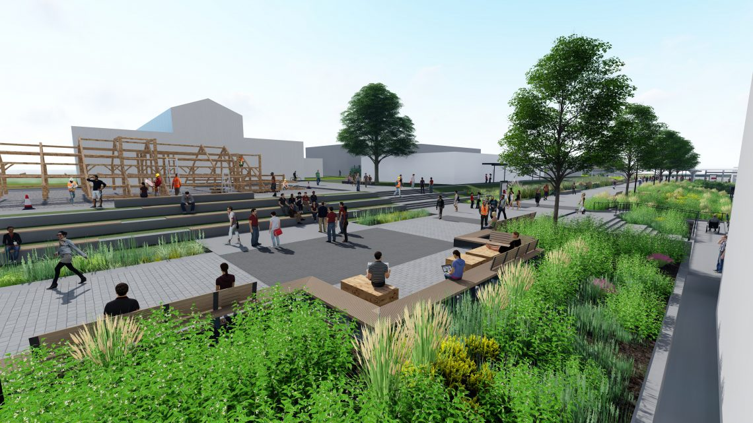

A rendering of above grade design elements along English Walk, part of the North Campus Infrastructure Project at BCIT. [Rendering provided by Stantec]

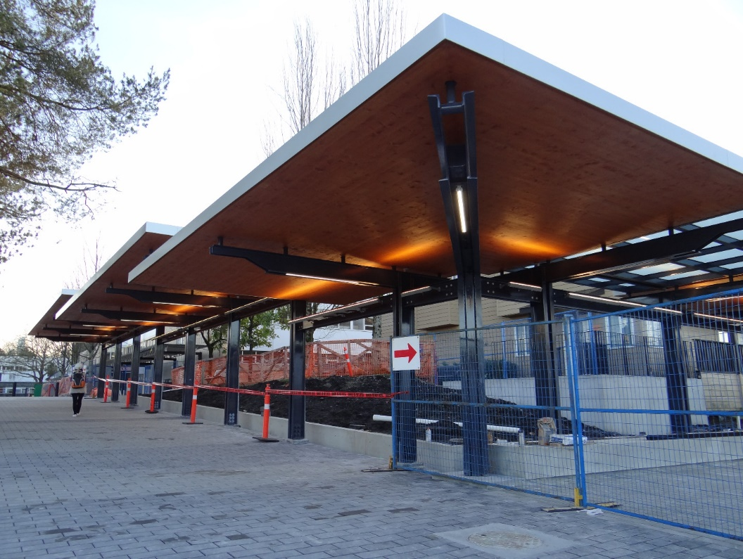

Photo: Newly-constructed, wheelchair-accessible canopy walkway with light-coloured pavers [provided by BCIT]